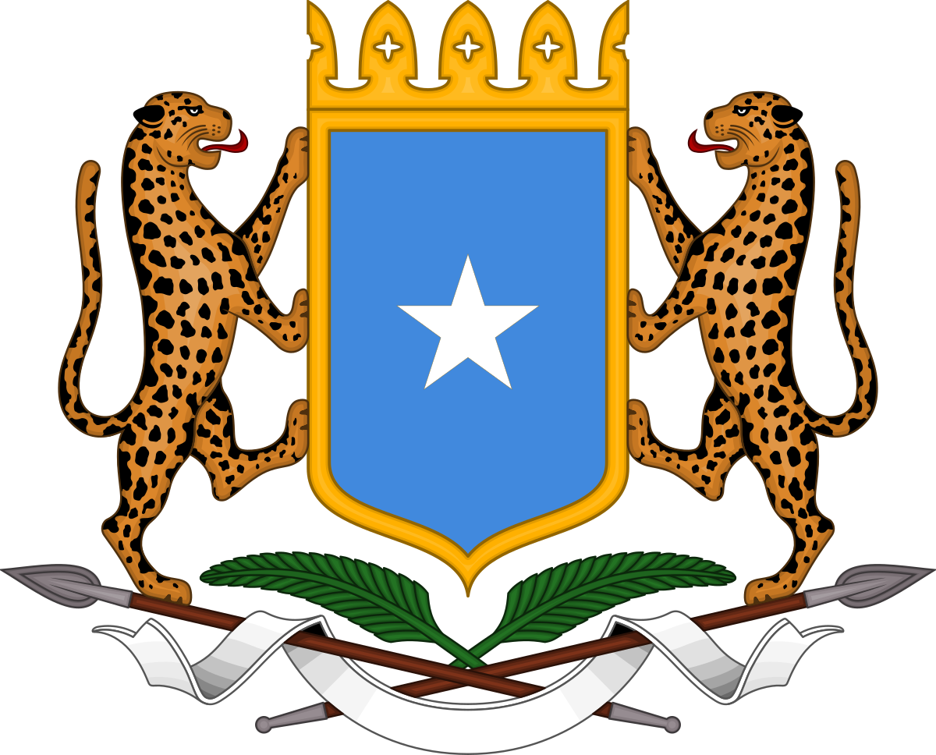
The Federal Republic of Somalia
Office of the Prime Minister
جـمـهـوريـة الصــومــال الفيـدرالية
مكتب رئيس الوزراء

Jamhuuriyadda Federaalka Soomaaliya
Xafiiska Ra’iisul Wasaaraha

Official delegation of Prime Minister of the Federal Republic of Somalia, H.E Hassan Ali Khaire, for his visit to USA.

S/No | Name | Title
1. | H.E Hassan Ali Khaire | Prime Minister, Federal Republic of Somalia
2. | H.E Abdirahman Duale Beileh | Minister of Finance
3. | H.E Gamal Hassan | Minister of Planning and Investment
4. | H.E Mohamed Mohamud Ali | Auditor General
5. | Fahad Dahir Ahmed | Director, NISA
6. | H.E Abdisaid M. Ali | National Security Advisor
7. | Abdullahi Aden Kullane | COS, NISA
8. | Abdullahi Liban Dahir | NISA
9. | Mr. Omar Abdirisak | Secretary General, BRA
10. | Mrs. Samira Gaid | Special Advisor PM
11. | Mr. Abdi Mohamed Abdullahi | Senior Advisor PM
12. | Mr. Alinur Salad | Director Communications

